# Project Plan

## Project Plant Schedule

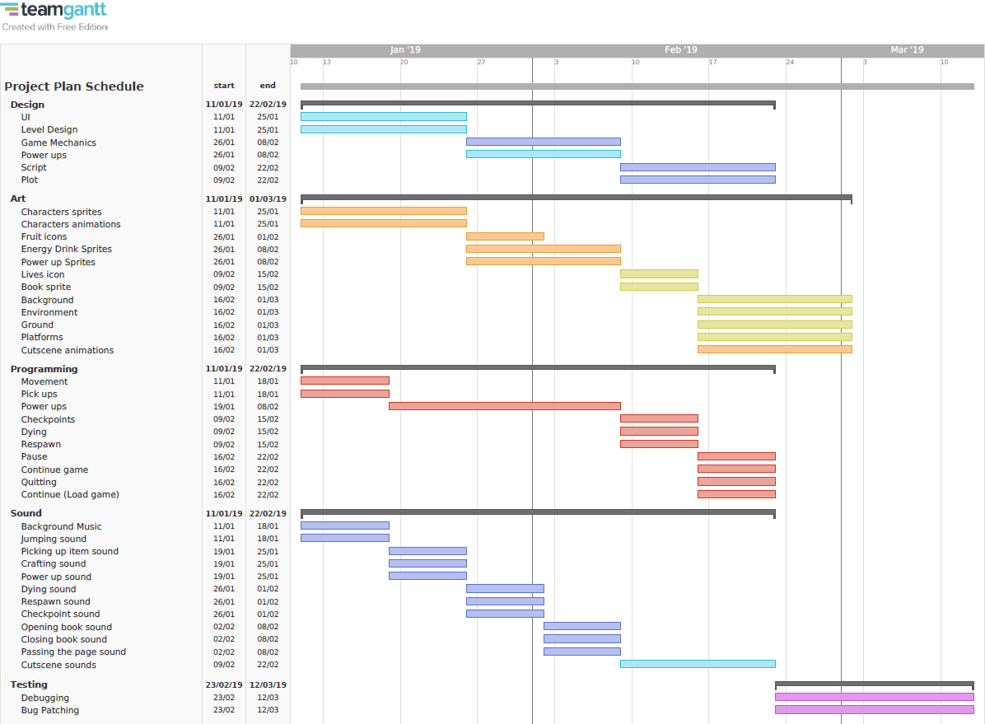

The Project Plan Schedule can be found in the following link: <https://github.com/YamilT52/DMP-Game/blob/master/Project%20Plan%20Schedule.pdf>

## Design

The design of the game will be composed of 6 main tasks: User Interface (UI), Level Design, Game Mechanics, Power Ups, Script and Plot.

The UI and Level Design have the highest priority because of how fundamental they are, without the UI the player would not be able to interact with the game, and without Level Design, there would not be a game at all. This is why both are the first tasks to be completed. The Game Mechanics and Power ups come next, they are complementary to each other and thus have to be made together. The Game Mechanics are the rules designed for interaction with the game, such as moving, jumping, running and therefore they create the gameplay, the Power Ups are part of the Game Mechanics and it’s the core of the game. Last but not least are the Plot and Script, they are also complementary to each other and so they are to be made together. The Plot is the sequence of events that will happen throughout the game and the Script is the narrative that the game will take. They need the previous tasks to be designed first so they can implement them into themselves. This is why the Plot and Script are the last tasks to be designed.

## Art

The art style of the game will be composed of 12 main tasks:

The Character Sprites and Animations have the highest priority as they will always be on screen. The amount of time given to create these assets is quite large because it is important that they are of high quality. The Fruit icons, Energy drink and Power up sprites are next, they are also very important as they are the entities the player will interact the most. The Lives icon, Book sprite, Background, Environment, Ground and Platforms are all fundamental to the game and they complement the previous tasks. Lastly are the Cutscene animations, to be created all previous tasks are needed and this is why they are made last.

## Programming

The programming section will be composed of 10 main tasks:

The Movement and the ability to Pick up items are essential to the game, this is why they are given priority and are made first. The Power Ups are the biggest challenge in the project to make, therefore they will be given the most amount of time. The Checkpoints, Dying and Respawn are tasks that are needed for the gameplay as well, so they are made third. The ability to Pause, Continue Game, Quit and Continue (Load Game) come last because they are not essential in the development process but important nonetheless, give the player control over the product.

## Sound

The sounds in the game are many and they will be done as 12 tasks:

The Background music is the most important of the sounds as this will make the game interesting and depending on which level and what are the circumstances the player finds himself in, the music will change to better suit the current situation giving the player a more immersive experience, this is why the Background Music is the first to be created. Action sounds like Jumping, Picking up items, Crafting, Powering Up, Dying, Respawning, reaching a Checkpoint, Opening and Closing a Book and Passing the page of the book are also very important as they function as feedback to the actions the player performs. The Cutscene sounds are made of they previous sounds, this is why is left at the end.

## Testing

The Testing will consist of 2 tasks:

Debugging and Bug Patching are very important, as they allow the creators to test the product and find errors, bugs, design flaws and such that need to be patched before the product is delivered.